Maritime Careers Exploration
Office Use Only
Received:__________
Student #:__________
MARIMED APPLICATION

July 25th to August 18th
Classes are held at our Kāne`ohe campus and field trips are at various locations around O`ahu.
Final class training activity is a multiple-day interisland sailing voyage followed by a completion ceremony.

Schedule: Summer B Class: July 25-August 18: 8:30 am to 3:30 pm (Monday to Friday) Voyage: August 10-16 Recognition Ceremony: August 18

Applicant Information

Name: (Full First) (Full Middle)

Name: (Last) Nickname/Preferred Name:

DOB: Age: Country of Birth

Are you Hawaiian/part Hawaiian? Yes No Gender: Male Female

Ethnicity (check all that apply) Native Hawaiian Other Pacific Islander American Indian or Alaska Native Asian
Caucasian Black/African American Prefer not to answer Other
Address:

Mobile Phone Number: Able to Text? Yes No

Email Address: Shirt size (Mens):

- Employment Status (check one): Part time Full time Unemployed Weekly Schedule: Name of Employer/Company:

- Current Annual Income (Not including public assistance): $

- Are you a single parent? Yes No

- Do you or your family reside in subsidized housing, emergency, or transitional housing, or receive food stamps or benefits from the Temporary Assistance for Needy Families program? Yes No

- Are you receiving federal financial aid in the form of a Pell grant? Yes No

- How will you get to classes? Drive Ride Share/Drop Off Bus Not Sure

Education

- Last School Attended or Currently Attending:
- Highest Level of Education Completed?
- Are you the first in your family to attend post-secondary school or college? Yes No
- Which of these did you receive? (check one) H.S. diploma GED Neither
- What high school did you attend for 12th grade?
- Did you take General Education courses in 2016 or 2017? Yes No
  - If so, did you pass all General Education courses with a C or better? Yes No
  - If you did not pass, state brief reason why.
- Did you take Vocational Education courses in 2016 or 2017? Yes No
  - If so, did you pass all Vocational Education courses with a C or better? Yes No
  - If you did not pass, state brief reason why.

Name:

Medical Information

Insuring Company: Member #:
Allergies: Asthma: Y N
List any current medical conditions that may impair your ability to fully participate in this hands-on, active learning experience:
List any requested American’s with Disabilities Act accommodations:

Emergency Contact (Primary):

Name: Relation:
Address:
Telephone No.: Email Address:

Emergency Contact (Secondary):

Name: Relation:
Address:
Telephone No.: Email Address:

Referral Information

How did you learn about the program? _____________________________________________

Who do you know that has completed the program? __________________________________

Please suggest ways that we might publicize or reach others who may be interested in this program: ____________________________________________________________________

Submit:
this application, and
1 copy of your birth certificate or proof of Native Hawaiian ancestry, and
1 copy of a valid picture ID, such as driver license, state ID card, passport,
TWIC card, or Merchant Mariner Credential

Applications may be faxed, emailed, or mailed to:
Maritime Careers Exploration
Attn: Molly Arthur
45-021 Likeke Pl.
Kāne`ohe, HI 96744

Fax (808) 247-0330
Molly.Arthur@Marimed.org

Call (808) 349-3774 if you have any questions; we’re happy to help.
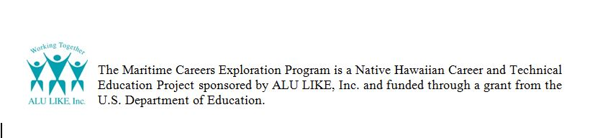
View class activities and job opportunities on Facebook Maritime.Careers.Exploration
6/2017

