Maritime Careers Exploration
Office Use Only
Received:__________
Student #:__________

MARIMED
May 23-June 16
Classes are held at our Kāne`ohe campus and field trips are at various locations around O`ahu.
Final class activity is an interisland ocean training sailing voyage.

Schedule is May 23-June 8: 8:30 am to 3 pm (Monday to Friday) AND June 9-13 voyage.
June 16 at 6 pm is the recognition ceremony.

Applicant Information

Name: (Full First) ______(Full Middle)

Name: (Last) __________________Nickname/Preferred Name: ______

DOB: Age: Country of Birth

Are you Hawaiian/part Hawaiian? (proof required) Yes No Gender: Male Female

Ethnicity (check all that apply) White Black or African American Asian American Indian or Alaska Native

Native Hawaiian Other Pacific Islander Refuse to answer Other

Address:

Mobile Phone Number: ___ Able to Text? Yes No

Email Address: ___________________________________

- Employment Status (check one): Part time Full time Unemployed Weekly Schedule: _____ Name of Employer/Company: _____
- Current Annual Income (Not including public assistance): $
- Are you a single parent? Yes No
- Do you or your family reside in subsidized housing, emergency, or transitional housing, or receive food stamps or benefits from the Temporary Assistance for Needy Families program? Yes No
- Are you receiving federal financial aid in the form of a Pell grant? Yes No

Education

- Last School Attended or Currently Attending:
- Highest Level of Education Completed?
- Are you the first in your family to attend post secondary school or college? Yes No
- Which of these did you receive? (check one) H.S. diploma GED Neither
- What high school did you attend for 12th grade?
- Did you take General Education courses in 2015? Yes No
  - If so, did you pass all General Education courses with a C or better? Yes No
  - If you did not pass, state brief reason why.
- Did you take Vocational Education courses in 2015? Yes No
  - If so, did you pass all Vocational Education courses with a C or better? Yes No
  - If you did not pass, state brief reason why.
Name:

Medical Information

Insuring Company: Member #:

Allergies: Asthma: Y N

List any current medical conditions that may impair your ability to fully participate in the program:

List any requested American’s with Disabilities Act accommodations:

Emergency Contact (Primary):

Name: Relation:
Address:
Telephone No.: Email Address:

Emergency Contact (Secondary):

Name: Relation:
Address:
Telephone No.: Email Address:

Referral Information

How did you learn about the program?__________________________________________________

Who do you know that has completed the program?_______________________________________

Please suggest ways that we might publicize or reach others who may be interested in this program:_________________________________________________________________________
________________________________________________________________________________

Applications may be faxed, emailed, or mailed to:
Maritime Careers Exploration, Attn: Jodie Yim
45-021 Likeke Pl.
Kāne`ohe, HI 96744

Fax (808) 235-1074
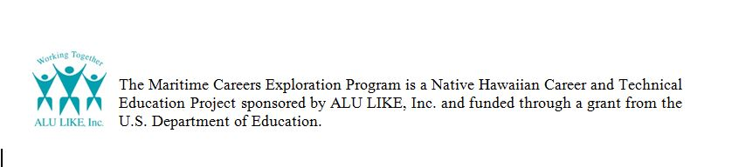
jodie.yim@marimed.org

11/2015

